Strategic Plan 2023-25

Feather Carriers – Leadership for Life Promotion Board Retreat

April 1-2, 2023, Wasauksing First Nation, Parry Sound, Ontario

Table of Contents

Introduction 3

Strategic Planning Process 3

Working Assumptions 3

Historical Scan 3

Purpose to Practice 4

Translate strategy to action. 4

Wisdom, Insights & Action 5

Historical Scan 6

Purpose to Practice 9

Translating Strategy to Action 14

Appendix – Three-Year Strategy Work Plan (April 2023 - March 2026) 16

Implementation Suggestions 21

Draft Board Workplan 21

# Introduction

Developing or revising a strategic plan is an important act of self-determination. It is a plan that builds on the lessons of the past and identifies an aspirational future that reflects the needs and vision of the Feather Carriers. The plan was developed by the Board on behalf of the communities and peoples it serves. This plan reaffirms the mission and vision, prioritizes strategies and their benefits along with an action plan to guide our work towards our vision. It’s an important and ongoing process to help us remain focused and coordinated in our vital efforts to spread our teachings and help people live long and good lives.

This refreshed strategic plan is intended to be a map of the next three years of our journey to promote the values and teachings of bimaadiziwin – a life well lived. It serves to help coordinate the work of Feather Carriers, and thereby supports us in the design and delivery of effective and meaningful programs to help us achieve our mission. The strategic plan will also help us communicate our mission and vision to others, including the circles of support we’ll nurture and nourish along our national organization’s path.

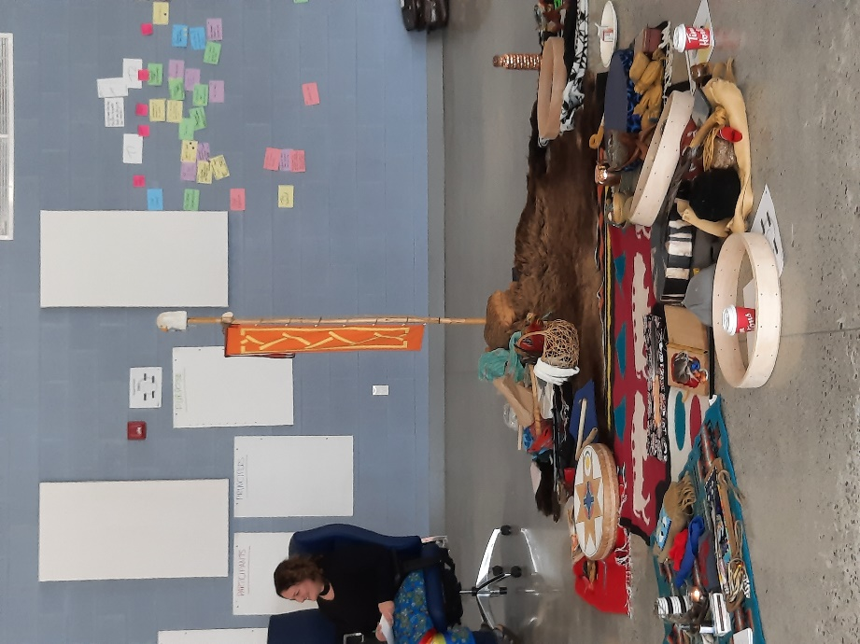The Board strategic planning retreat was a positive way for us to come together in person for gathering, ceremony, reflection, and collective visioning toward a clearly articulated shared purpose rooted in the indigenous worldview, informed by our teachings, and focused on our priorities, and key activities. This plan will form the foundation of our work, with its action plans implemented, continuously reviewed, and updated as a living guide for the Board, management team, and our partners. The plan must remain a fluid and integral piece of all our activities and deliberations, including annual planning, decision making. The strategic plan needs to infuse all we do if we hope to meet its exciting and ambitious goals.

# Strategic Planning Process

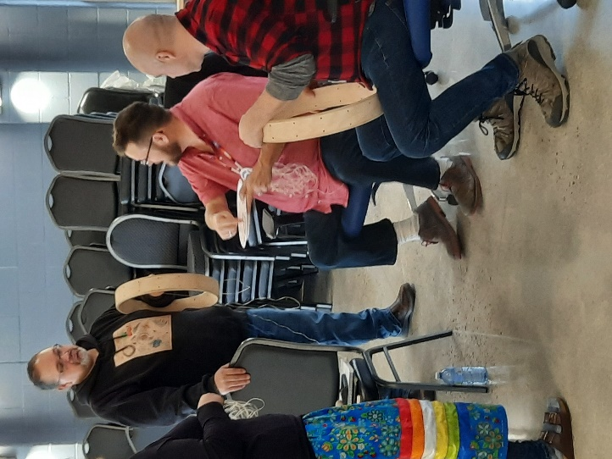This strategic plan represents the three-year planning cycle for the Feather Carriers and builds upon the previous strategic planning documents*.* The key elements of the current strategic planning process are outlined below.

Rational Objective: Develop a shared practical vison accompanied by a concrete action plan for the next 1-2 years.

Experiential objective: Participants build personal relationships, sharpen their personal commitment, and build a sense of coherence as a highly aligned group.

Deliverable: A concise strategic plan documenting the Board’s practical vision, key opportunities, broad strategic directions, and concrete action plan with tasks, timelines, and responsibilities.

## Working Assumptions

* **Everyone has wisdom.**
* **We need everyone’s wisdom for the wisest result.**
* **There are no wrong answers.**
* **The whole is greater than the sum of its parts.**
* **Each person will hear others and be heard.**

These assumptions were grounded in the seven sacred teachings of Humility, Bravery, Honesty, Wisdom, Truth, Respect, and Love

## Historical Scan

The Technology of Participation Historical Scan provides a way for team members to review the past, envision the future, celebrate successes, and get to know each other. The Historical Scan can help all team members get quickly on top of the major happenings and accomplishments of the team. By aggregating individual memories into collective memories, the team can also stop and learn from what has been done. Where teams have personal conflicts or rifts, the Historical Scan can allow healing to occur by recognizing the contributions of all parties and bring closure to the past.

The Historical Scan visually records the events of the past, the high**s** and the lows that the team members have experienced, the turning points in the history of the group. A story is created of the history of the group.

## Purpose to Practice

By using Purpose to Practice at the start of an initiative, the stakeholders can shape together all the elements that will determine the success of their initiative. The group begins by generating a shared purpose (i.e., why the work is important to each participant and the larger community). All additional elements—principles, participants, structure, and practices—are designed to help achieve the purpose. By shaping these five elements together, participants clarify how they can organize themselves to adapt creatively and scale up for success. For big initiatives, Purpose to Practice makes it possible to include many stakeholders in shaping their future initiative.

1. *Purpose: Why is work important to you and the larger community?*
2. *Principles: What rules must we absolutely obey to succeed in achieving our purpose?*
3. *Participants: Who can contribute to achieving our purpose and must be included?*
4. *Structure: How must we organize (both macro- and microstructures) and distribute control to achieve our purpose?*
5. *Practices: What are we going to do? What will we offer to our users/clients and how will we do it?*

Purpose to Practice is helpful for several reasons.

* Engage and focus everyone’s imagination in designing the collective future of participants.
* Avoid “design” by a small group of people or experts-only behind closed doors.
* Pull together all the elements needed to launch and sustain an effort, thereby avoiding a fragmented process.
* Create innovative strategies that can be implemented and spread quickly because there is shared ownership.
* Increase resilience and the ability to absorb disruptions by distributing power fairly.
* Build the capacity to rapidly adapt any of the elements to changing circumstances.

## Translate strategy to action.

At this point in the day, participants should have a compelling story about their shared purpose, along with a shared vision of what they will work toward, likely over the next few years – i.e., the ‘what’ and the ‘why’. The afternoon is all about taking that sense of purpose and outlining the series of stages and specific actions to be taken, by when and by whom. This is translating strategy into action. The output of which will be the operational part of the planning process, setting the team up to leave the workshop committed and ready to take concrete action to make their vision a reality.

It's important for teams to define quantifiable goals that are inherently linked to the strategy and to the participants that contribute to organizational performance. With a strategy’s key measures of success identified, participants then spend important time considering their strengths, opportunities, internal contradictions and barriers, and practical, meaningful action plans. Through this discussion the team will agree on a series of hypotheses and wise, measurable accomplishments. These ought to be the integrated sense that the team can impact and realize together. These are then woven together into an action plan with its own component measures of progress, timelines, and roles and responsibilities. The strategic planning process, implementation and pathway making is balanced in being spirit-led, centering community need, Indigenous Wisdom, uplifted in two-eyed seeing - other ways of knowing.

# Wisdom, Insights & Action

**Vision**

*We envision a world where all of life is embraced, accepted, honoured, and promoted throughout time immemorial.*

**Mission**

*Feather Carriers Leadership for Life Promotion is a grassroots movement that activates a paradigm shift, generating systemic change, social innovation, and collective impact.*

*We promote deep roots to thrive, while providing the space and traditional teachings to grow through our stories of change. Together we carry our ancestral knowledge forward, and uplift a spirit of hope, meaning, belonging and purpose.*

*We are dedicated to a re-storying our inherent power and establishing pathways towards a long, fulfilling life and natural death. We commit to meeting all people where they are on the life path, including supporting survivors of premature unnatural death and those who are grieving the loss of loved one from premature unnatural death.*

**Values**

*We are guided by spirit and walk in relationship with our individual and collective values, always giving space for them to deepen, be expressed, and come together – to nurture the collective good mind.*

*We gather our values through the wisdom of our stories of life and creation. Feather Carriers values are grounded in promoting life and reflect our collective teachings of natural law, diplomacy, inclusivity, and integrity – fundamentally meeting life and all beings where they are on their life’s journey.*

## Historical Scan

The Feather Carriers: Leadership for Life Promotion initiative began in 2015 as community mobilization strategy and collaborative life promotion training approach. The programme was initiated by Dr. Ed Connors, Elder John Rice and Dr. Debby Wilson Danard, along with a number of local indigenous advisors and mental health agencies in the regions of North Simcoe and Muskoka. Together, the founders successfully harmonized expertise in clinical science with traditional knowledge and community experience rooted in the local Haudenosaunee/Anishinaabe peoples. A harmony that became a new option for Indigenous and non-Indigenous peoples looking to address suicide prevention and loss.

At its core, Feather Carriers is founded The Miikaans teachings – the Anishinaabe or Ojibwe teachings on life. The teaching tells the story of how we begin life as Spirit coming into physical form, how that’s done with Creator, and how this is an agreement of how we’re going to enter into this journey. The teachings go on to tell of the seven stages of life, culminating in the Spirit leaving the body and returning into the Spirit world.

Figure 1: Miikaans Teaching Resource Elder John Rice

The training starts with the belief that life is worth living and aims to develop community leaders through application of Indigenous knowledge and cultural understandings of life promotion. The programme grew from the natural relationship with the land, local knowledge, and natural language of local Indigenous communities, and was designed to connect with individuals and families at risk of premature death we as well as supporting survivors of loss.

This approach addresses the need among local communities that were asking for new ways to address suicide from their cultural perspectives, to explore their complex history of intergenerational trauma, and offer ongoing follow-up and support to participants in the programme. The Feather Carriers approach went further and shifted the focus from suicide prevention to a more affirmative view in life promotion, with core practices embed in an Indigenous world view rooted in individual and group reflection and growth as part of the journey towards bimaadisiwin (the good life).

The Historical Scan set out to answer the question *What are the key shifts and trends that are driving our current reality?* In so doing, participants reflected individually and collectively on key events related to the individuals in the Board, the wider organization, the larger region/province/nation, and the world at large. Individual events were placed on a timeline, and participants reflected on patterns, trends, shifts and named key periods and the journey overall. Figure 1 represents the key time periods in the Feather Carriers organizational journey to date, along with representative insights and key moments.

Figure 1. Historical Scan: Key Periods and Turning Points

## Purpose to Practice

Figure 2. Purpose to Practice (Lipmanowicz & McCandless, 2014)

**Purpose:** Intergenerational life promotion led by spirt.

The discussion of purpose formed the basis for the rest of the exercise, and the rest of the retreat. All subsequent conversations needed to reference their ability to serve this purpose, which further expressed through the following aspects:

* Responsibility to care for individuals, family, community – to use our gifts for this.
* An ability to address grief & loss.
* Survival of us as indigenous people – our collective future.
* Finding a language to allow for transformation & healing.
* So children don’t need to grow up in residential schools, systems transformation; break the cycle of institutionalization and re-institutionalization.
* Awaken something to energize life – joy
* Understand our own human experience and help others do the same: We are spiritual beings having a human experience.
* Help others find joy and purpose and live our gifts.
* There’s a message and voice needed.
* It’s a calling – a driving force.
* The spirit calls.

**Principles: Be rooted in indigenous worldview.**

To effectively pursue the Feather Carriers purpose, the organization and its core members including the Board must commit to work to uphold the following principles. These beliefs are integral to how Feather Carriers will do their work internally and externally. No elements shall be played off against another. Instead, these are seen as critical ‘must dos’ in our regular operations and relations, and none shall be ignored at the benefit of the other. The challenge is to make space for all to be true in whole, to best serve the purpose.

* Practice the multiplicity of two-eyed seeing, in being centered in Indigenous knowledge and ways of being, while recognizing and weaving forward the value of non-Indigenous knowledge; to help us gain a more complete and holistic understanding of the world. We live into the spirit of our prophecies and the challenges we face to wayfind approaches and pathways through complex problems.
* Be intentionally inclusive – intergenerational, as well as recognizing that Indigenous and non-Indigenous peoples are equals in the pursuit of our shared purpose of a good life.
* Regularly participate in reflective practice (e.g., ceremony).
* Be loving, kind, accepting, non-interfering, belonging, cultural safety.
* Be a self-sustaining organization.
* Remain mother earth connected.
* Live into prophecy stories.
* Be careful to avoid proselytizing.
* Be adaptive and embrace change and avoid being overly standardized.
* Take a global perspective – seven generations.
* Remember our roots to move forward. We are the roots of the tree. We *are* the community – not speaking to it.
* Embrace our traditional governance vision and the eight-pointed star, 7 clan system as a way to organize, engage, and empower.

**Participants:** **A Community of Support**

******Board members used a loose framework of support envisioned as a series of concentric circles, with the purpose in the centre. Participants were identifed by their roles in ever expanding concentric circles. Key roles in the dicussion focussed on those who are doers (e.g.m, Managementr team), those whose input and advice we seek (e,g, teachers), those whose support we cannot do without (e.g., elders) and those who need to be aware of Featrher Carriers (e.g., the community)

Table 1. Community of support to advance Feather Carriers purpose

|  |  |  |  |
| --- | --- | --- | --- |
| *CORE LEVEL -DOERS* | *INVOLVEMENT* | *SUPPORT* | *AWARENESS* |
| Ambassador stream | Participants / cohorts | Ambassadors | Federal and provincial government partners  COO, AFN |
| Board | Ozhiitaajig | Grandmothers/Elders circle |
| Teachers of teachers | Teachers | Funders & Donors |
| Staff / organization team | Police Services | Partnerships – supporting relations (allies) | Community partners – Friendship Centres, Bands |
| Indigenous knowledge keepers | Miigwanaabik – Feather Carriers | FPWC, Thunderbird | Health Related Partners – CASP, Indigenous healing organizations |
| Mystery / spirit | Partnerships – global, national, local to show movement | Charitable status partners |
| Elders | FC voice of people | Knowledge keepers & Elders from different nations |  |
| LGBTQ+ | Elders intergenerational circle |  |
| Ozhiitaajig | Youth with lived experience |  |  |

**Structure: Dream Drum (eight-pointed clan system)**

The Feather Carriers Governance strucutre sits within our dream drum. The living sphere of the dream drum and inner weave of relational governance comes to life where the Eagle Staff meets and rests within the heart-beat of our Turtle, AkiiKwe, Mother Earth, and is alive constantly moving, turning, exchanging.

Seven Watershed Regions across Turtle Island will be weaved into the dream drum, together with the clan system. The inside weave, circle inside the star represents our grandmothers – Elders circle, which also reflects the outer hoop of the dream drum, and the 8th point in the star. Visualizing and visioning the 8-pointed star blanket in motion to generate the great rainbow of our prophecies.

Feather Carriers governance continue to transition from a contemporary spirit of the relational Anishinaabe 7-pointed Clan system, to the 8-pointed Star Blanket, guided by Zahgausgai, Elder John Rice.

A more fulsome reflection and description of this governance model is available in *Feather Carriers Governance Revolution*

**Practices:** **Bimaddiswin – Sharing the teachings – Telling our stories**

Participants took part in a consensus workshop (Appendix) to address the core questions of the retreat. Through the discussion three strategic themes emerged, with seven strategic objectives. These were elaborated into specific three-year action plans.

## Translating Strategy to Action

#### Theme 1: Bimaddiswin

##### Objective: Flourishing / Sustainability IMAGE – dream drum eight point

In three years, we want to see full policies and procedures, charitable status, abundant and sustainable resources, healthy relationships with our communities, reciprocity and strong communication, well defined organizational structure in traditional governance, ceremony and encouraging life promoting ways wholistically. This is important because we will not only survive but thrive as a healthier, well Indigenous peoples leading long and good lives in our lands – as our prophecies of healing point us toward. This will look like:

* Full set of policies and procedures that are embodied wholistically with two-eyed seeing.
* Gain charitable status.
* Healthy and abundant resources from multiple relationships and revenue streams.
* Land based teachings.
* Sacred spaces and places to share teachings and our stories.

##### Objective: Spirit Led IMAGE – Eagle staff

In three years, we want to see spirit continuing to lead the unfoldment of Feather Carriers so that the shape and structure is determined through our Indigenous teachings. This is important because everything comes from spirit, and we need to honour and respect all that spirit teaches us. In this way we create a living balance for ourselves, which equates with long and good lives. This will look like:

* National gathering of Feather Carriers honoured in ceremony.
* Life promotion teachings and ceremonies built and shared from across Turtle Island.
* Elders, ambassadors, grandmothers working collectively.
* Everything we do is grounded in ceremony.

##### Objective: Reflective Practice IMAGE - Sweat Lodge

In three years, we want to see our structures and practices alive, like our teaching lodge of life and what we know promotes our spiritual and wholistic health, individually and collectively. The sweat lodge, Jim Dumont said according to John, is the place where you can look back through your life, even before your birth. This is important because our teachings within life promotion need to be nurtured inward as well as outward to be integral and alive within our natural law and growth. This will look like:

* Regular spiritual practices together led by our Elders’ Circle. This would include sweat lodges the day before every big decision (such as the AGM). These act as maintenance for the health of our relationships and our visions.
* Revisiting annually sacred areas in the land such as Snake Rock.
* The G’Chi Odewey jig will grow to 7 -8 regional board members, reflecting the contemporary clan structure. By doing so there will be someone in each clan, carrying the skills and outlook for that aspect of the group, giving us greater balance and resources.
* The Board will continue to grow with our watersheds, to receive the guidance and vision across the land.
* Regular connections to the wider community and each other, through events such as the eagle staff feast, the AGM, and the offering of tobacco by cohort leaders. Practices such as this build fidelity to the organization and help build stronger bonds between members.

#### Theme 2: Sharing the Teachings

##### Objective: Develop Teachers IMAGE – Infinity symbol

In three years, we want to see full policies and procedures, charitable status, healthy and abundant funding, good relationships with our communities, good reputation, well defined organizational structure, and encouraging life promoting ways wholistically. This is important because we will not only survive but thrive as a healthier, well Indigenous peoples leading long and good lives upon our lands – as our prophecies of healing point us toward. This will look like:

* Youth cohort
* Elders Engagement and role of Ambassadors.
* Program Coordinator

##### Objective: Teachings & Program Development IMAGE - 8-pointed star

In three years, we want to see a flourishing suite of Feather Carriers programming and team, evolving to meet our communities needs by offering Feather Carriers teachings on a good death in postvention and co-designing a youth led Feather Carriers cohort. This is important because in our community constellations (consultations) we heard the need and request for life promotion to include teachings across the lifespan. This will look like:

* Program Coordinator
* Feather Carriers 2.0
* Full time teachers
* Youth program

#### Theme 3: Telling Our Stories

##### Objective: Engage in Dialogue IMAGE - Soaring eagle

In three years, we want to see communications as a vital part of Feather Carriers sustainability; active network of feather carriers engaged in spreading the dialogue; active local hubs, regional watersheds; people moving through multiple levels of engagement with the organization. This is important because it helps promote life through an indigenous world view; gives a new language to help shift the dialogue from one of illness to one of wellness and normalizing death and dying. This will look like:

* A staff communications specialist
* Communications plan
* A community of support for Feather Carriers cohorts; interconnected, with a life of its own.

##### Objective: Learning Through Storytelling and Listening IMAGE - rainbow chameleon / circle of life

In three years, we want to tell our stories through meaningful evaluation, mapping and research on Feather Carriers in Leadership and Life Promotion. This is important because we want to be able to share and demonstrate the value of Feather Carriers to different communities. This will look like:

* Evaluation through an Indigenous lens and understanding of research as ceremony.
* Involve Ozhiitajig in evaluation planning.
* Have a partnership for a research ethics board.
* Be eligible to apply for tri-council funding.
* Have a platform to gather and analyze data to tell our stories.
* Theory of change, social impact evaluation and systems mapping.

# Appendix – Three-Year Strategy Work Plan (April 2023 - March 2026)

|  |  |  |  |  |  |  |  |
| --- | --- | --- | --- | --- | --- | --- | --- |
| **Strategic Theme: Bimaddiswin** | | | | | | | |
| Objective | Activities | Owner | Timeline | Key Factors to Success | Likely Obstacles | Already Done | |
| 1. Flourishing / Sustainability | * Confirm charitable status. * Core Board policies & procedures * Sacred spaces & places | * Program Manager, Board * Board * Board, Elders | * In progress * 2024-25 * 2025-26 | * Feather Carriers Community * Relationships and partnerships * Multiple funding streams | * Different communication styles * Practicing our teachings * Colonization | * Getting ready to share our gifts. * Early stages nurturing | |
| 1. Spirit Led | * Elders circle * Grandmother’s circle * Youth led circle. * Ceremony: Review programming * Preschedule ceremonial events one year in advance. * Dream drum society * Hoodies, t-shirts * AGM: clan system, sweat lodge, visioning, | * John, Ed, Shane * Erin, Laura * Board, Program Manager * Elders circle, grandmothers * Program Manager, Board, elders, circles * John, Nick * Program Manager * Board | * 2024-25 * 2024-25 * 2023-24 * 2023-24 * 2025-26 * 2023-24 * Ongoing * Ongoing | * Ambassadors, elders, grandmothers circle connected to star clan. * Youth led circle. * Everything grounded in ceremony (eagle staff feast, dream drums), and natural las | * Listening skills that limit our ability to learn widely and fully from each other. * Time: Making space and time to vision widely * Thinking inside the box |  | |
| 1. Reflective Practice | * Regular spiritual practices together led by our Ambassadors - Elders’ Circle. * Recruit Board members – each position carrying the skills and outlook for that aspect of the clan governance. * Recruit Board members to reflect the watersheds nationally * Eagle staff feast   / AGM | * Ambassadors, Elders’ Circle * Board * Program Manager, finance officer (guidance from Board and ambassadors. | * Immediately * 2023-2024 * Ongoing | * Role of Ambassadors and Elders, development of elder’s circle * Ongoing teachings and guidance with the clan governance * Consistency – spiritual practices and in-person events are prioritized. * Application of two-eyed seeing (etuaptmumk) to our thinking | * Colonized thinking, e.g., how communities govern themselves through the structures imposed by the Indian Act, * Lack of a strategic plan * Not looking backwards to know where you came from * No road map. * Not coming together * Not slowing down in order truly travel well | * Already some of the foundational planning is done. * Fires at Nick’s place and Ed’s backyard, | |
| **Strategic Theme: Sharing the Teachings** | | | | | | |  |
| Objective | Activities | Owner | Timeline | Key Factors to Success | Likely Obstacles | Already Done | |
| 1. Develop the Teachers | * Youth program * Elders program | * Program coordinator, elders, ambassadors * Program coordinator, elders, ambassadors | * 2024-25 * 2024-25 | * Ozhiitaajig and teachers retreat. * Develop active Ozhiitaajig and teachers. * Develop youth cohorts. * Develop elder cohorts. * Youth camp in partnership with existing camp | * How to engage youth T & O * How to engage elders * $$ for camp | * Ozhiitaajig and teachers * Training program for Ozhiitaajig and teachers * Recruitment from Ozhiitaajig and teachers | |
| 1. Teachings & Program Development | * Feather carriers 2.0 * Youth program * Full-time teachers * Quality improvement education, fidelity | * Program Coordinator * Clan System Triads * Founders / Elders Circle * Teachers | * TBD * 2023-24 * 2025-26 | * Board development * Ambassadors * Stable funding * Relevant programming * Enough teachers to do the work. * Train the trainers * Teacher community of practice * Spirt-led, fluid. * Quality improvement | * Casual teachers * Different skills needed to teach youth. * F/C certification * Cohort recruitment * Maintaining fidelity | * Feather carriers’ program * Ozhiitaajig * Some teachers (casual, contract) | |
| **Strategic Theme: Telling Our Stories** | | | | | | |  |
| Objective | Activities | Owner | Timeline | Key Factors to Success | Likely Obstacles | Already Done | |
| 1. Engage in Dialogue | * Communication officer | * Ambassadors | * 2025-26 | * Communications role * Communications plan * Consent for sharing contact information. * 2-way communication platform * Content and content developers | * Funding * No technology * Different audiences use different technology. * Inspiring those outside the organization to engage in promotion / content creation | * Contact list * Social media channels * Potential F/C participants * Governance * Staff (Program Manager, Christine) * Ozhiitaajig * Cohorts | |
| 1. Learning Through Storytelling and Listening | * Meaningful program evaluation of current programming * Have a platform to gather and analyze data. * Involve Ozhiitaajig in planning. * Eligible for Tri-Council funding * REB partnership * Create theory of change | * 8 clans, Program Manager, Ozhiitaajig, teachers, feather carriers, ambassadors, elders, grandmother circle * Clan Triad with Christie * Bird Clan, Program Manager, Ambassadors * Clan Triad with Program Manager * Clan Triad with Program Manager * Nick (visual), Erin, Laura | * 2024-25 * 2024-25 * 3 months * 2024-25 * 20224-25 * 6 months | * Participants and providers help construct research. * Participatory action research * Integrated knowledge translation and other participatory approaches * Research as ceremony = guiding principle * Two eyed seeing * Quantitative & qualitative data * Process & outcome evaluation * Impact evaluation * Gather data throughout the program cycle. * Psychometrically sounds measures. * Electronic survey platform * Data that speak to different audiences * Impact stories * Data collection and analysis plans * Training plan for data collection * Eligible for TRI council funding * Partnerships * Have a theory of change. * Systems impact mapping * Flourishing social media accounts * OACP principles * Data governance | * Grant writing expertise * Expensive data analysis software * Training on R to implement (R is free and best in class) * Cloud based data collection security. * Paper and pencil evaluation – time consuming * Measures that don’t yield actionable information. * Data ownership – need MOU with partners. * No access to REB * No consensus on ideas of how to do evaluation. * Can’t access previous evaluations. * Varied research / evaluation skills on team | * Past evaluations (currently with BANAC) * Past evaluation protocol * Call out to Ozhiitaajig for feedback. * Community constellations – what’s missing, what do we need to do next? | |

Note: Leaning through story telling groups might consider clustering & naming and/or prioritizing their numerous ideas

### Implementation Suggestions

The strategic planning exercise is beneficial for articulating a shared vision of the Feather Carrier’s values, areas of strategic focus, and key activities. This must be only the beginning of the journey if the many intended benefits are to be achieved. To yield the greatest possible benefits from this strategic planning exercise, it must be implemented in ways that help the Board, the staff and other key stakeholders act and assess progress. This plan must inform annual planning, budgeting, ongoing decision making, and regular reporting to the Board, funders, and / or stakeholders. The following recommendations can help various users speak to the strategic plan, its inspiration, its vision, goals, and activities.

* Develop measures / markers of development and impact that can be easily gathered and reported at least annually, if not quarterly.
* Carry / post the strategic plan to keep it clearly visible to staff and contributors as often as is possible.
* Review the strategic plan with new staff, Board members, key contributors.
* Staff and Board review progress toward the strategic plan timelines at least once quarterly.
* Use the plan to set annual goals and allocate financial and human resources.
* Align staff, Board committees, clans to the strategic themes/ objectives.
* Post the strategic plan on website, share via social media, share with key partners as part of a formal communication plan.

### Draft Board Workplan

* Networking, relationship building, outreach plan focused on our strategic goals.
* Board development and recruitment
* Evolve the governance model.
  + Roles and responsibilities of each clan
  + Consensus building
  + Conflict resolution